EX15 B073012012 詹晏丞

(一) 15-1(a)

%BER for MIMO systems (OSTBC)

% 2x2 & 2x4

clear all;

SNR_dB=[0 3 6 9 12];

N=10^5;

Nt=2;

Nr= [2 4 6 8];

T = 2;

Count_BER=zeros(length(Nr),length(SNR_dB));

for m = 1:length(Nr)

for n=1:length(SNR_dB)

SNR=10^(SNR_dB(n)/10);

N0=4/SNR;

for t=1:N

%------------------------------------------

%generate channel

H=(randn(Nr(m),Nt)+j*randn(Nr(m),Nt))*sqrt(1/2); % MIMO channel

%-----------------------------------

%generate tx & rx signal -- 2 bits

b=floor(rand(2,2)*2); % one-bit data

xb=(-1).^b; % {0 1}-->{1 -1}

x = xb(: , 1) + j * xb(: , 2);

S=[x(1) x(2); -x(2)' x(1)'];

w=(randn(T,Nr(m))+j*randn(T,Nr(m)))*sqrt(N0/2); % AWGN

y=S*H.'+w; % NxNr ±µ¦¬°T¸¹

%-------------------------------------

A1=[1 0; 0 0];

A2=[0 1; 0 0];

B1=[0 0; 0 1];

B2=[0 0; -1 0];

z=zeros(2,1);

for t=1:Nr(m)

z(1)=z(1)+conj(H(t,:))*A1'*y(:,t)+y(:,t)'*B1*H(t,:).';

z(2)=z(2)+conj(H(t,:))*A2'*y(:,t)+y(:,t)'*B2*H(t,:).';

end

b_hat=zeros(2,2);

b_hat(1,1) = (real(z(1)) < 0) ;

b_hat(1,2) = (imag(z(1)) < 0);

b_hat(2,1) = (real(z(2)) < 0) ;

b_hat(2,2) = (imag(z(2)) < 0);

Count_BER(m,n)=Count_BER(m,n)+sum(abs(b_hat-b),'all');

end

end

end

BER=Count_BER./(4*N);

semilogy(SNR_dB,BER);

legend('Nr=2','Nr=4','Nr=6','Nr=8');

xlabel('SNR (dB)');

ylabel('Probability of bit errors');

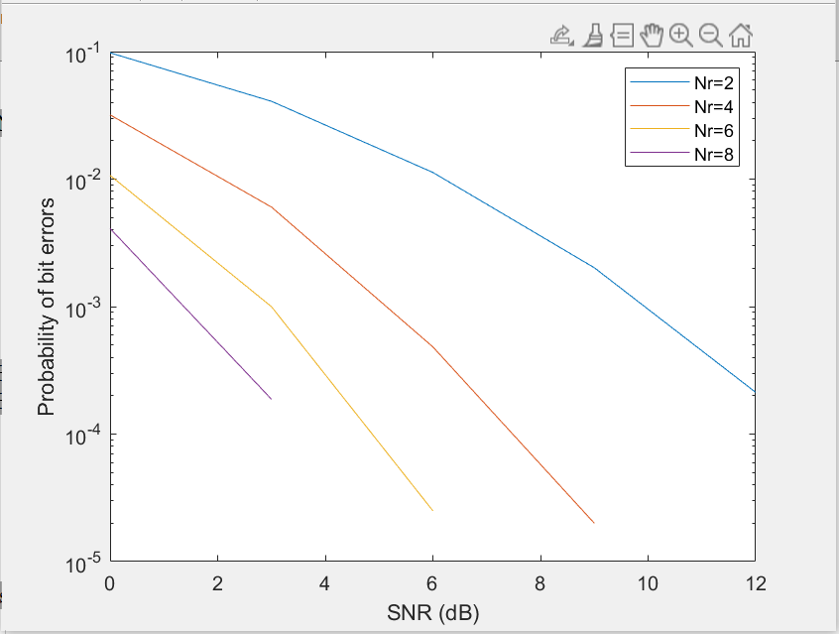

(二)15-1(b)

%BER for MIMO systems (OSTBC)

% 2x2 & 2x4

clear all;

SNR_dB=[0 3 6 9 12];

N=10^4;

Nt=3;

Nr= [2 4 6 8];

T = 4;

Count_BER=zeros(length(Nr),length(SNR_dB));

for m = 1:length(Nr)

for n=1:length(SNR_dB)

SNR=10^(SNR_dB(n)/10);

N0=9/(2*SNR);

for t=1:N

%------------------------------------------

%generate channel

H=(randn(Nr(m),Nt)+j*randn(Nr(m),Nt))*sqrt(1/2); % MIMO channel

%-----------------------------------

%generate tx & rx signal -- 2 bits

b=floor(rand(3,2)*2); % one-bit data

xb=(-1).^b; % {0 1}-->{1 -1}

x = xb(: , 1) + j * xb(: , 2);

S=[x(1) x(2) x(3); -x(2)' x(1)' 0; x(3)' 0 -x(1)' ; 0 x(3)' -x(2)'];

w=(randn(T,Nr(m))+j*randn(T,Nr(m)))*sqrt(N0/2); % AWGN

y=S*H.'+w; % TxNr

%-------------------------------------

A1=[1 0 0; 0 0 0;0 0 0;0 0 0];

A2=[0 1 0; 0 0 0; 0 0 0; 0 0 0];

A3=[0 0 1; 0 0 0;0 0 0;0 0 0];

B1=[0 0 0; 0 1 0; 0 0 -1; 0 0 0];

B2=[0 0 0; -1 0 0; 0 0 0;0 0 -1];

B3=[0 0 0;0 0 0;1 0 0;0 1 0];

z=zeros(3,1);

for t=1:Nr(m)

z(1)=z(1)+conj(H(t,:))*A1'*y(:,t)+y(:,t)'*B1*H(t,:).';

z(2)=z(2)+conj(H(t,:))*A2'*y(:,t)+y(:,t)'*B2*H(t,:).';

z(3)=z(3)+conj(H(t,:))*A3'*y(:,t)+y(:,t)'*B3*H(t,:).';

end

b_hat=zeros(3,2);

b_hat(1,1) = (real(z(1)) < 0) ;

b_hat(1,2) = (imag(z(1)) < 0);

b_hat(2,1) = (real(z(2)) < 0) ;

b_hat(2,2) = (imag(z(2)) < 0);

b_hat(3,1) = (real(z(3)) < 0) ;

b_hat(3,2) = (imag(z(3)) < 0);

Count_BER(m,n)=Count_BER(m,n)+sum(abs(b_hat-b),'all');

end

end

end

BER=Count_BER./(6*N);

semilogy(SNR_dB,BER);

legend('Nr=2','Nr=4','Nr=6','Nr=8');

xlabel('SNR (dB)');

ylabel('Probability of bit errors');

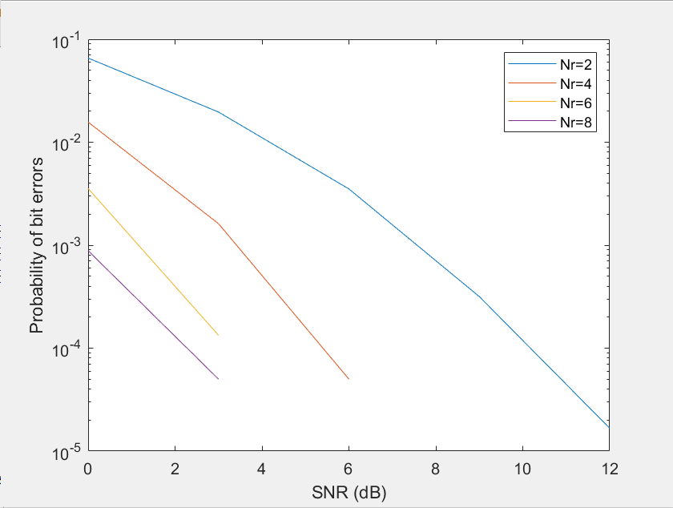

(三)15-1(c)

%BER for MIMO systems (OSTBC)

% 2x2 & 2x4

clear all;

SNR_dB=[0 3 6 9 12];

N=10^4;

Nt=4;

Nr= [2 4 6 8];

T = 4;

Count_BER=zeros(length(Nr),length(SNR_dB));

for m = 1:length(Nr)

for n=1:length(SNR_dB)

SNR=10^(SNR_dB(n)/10);

N0=6/(SNR);

for t=1:N

%------------------------------------------

%generate channel

H=(randn(Nr(m),Nt)+j*randn(Nr(m),Nt))*sqrt(1/2); % MIMO channel

%-----------------------------------

%generate tx & rx signal -- 2 bits

b=floor(rand(3,2)*2); % one-bit data

xb=(-1).^b; % {0 1}-->{1 -1}

x = xb(: , 1) + j * xb(: , 2);

S=[x(1) x(2) x(3) 0; -x(2)' x(1)' 0 x(3); x(3)' 0 -x(1)' x(2) ; 0 x(3)' -x(2)' -x(1)];

w=(randn(T,Nr(m))+j*randn(T,Nr(m)))*sqrt(N0/2); % AWGN

y=S*H.'+w; % TxNr

%-------------------------------------

A1=[1 0 0 0;0 0 0 0;0 0 0 0;0 0 0 -1];

A2=[0 1 0 0;0 0 0 0; 0 0 0 1;0 0 0 0];

A3=[0 0 1 0; 0 0 0 1;0 0 0 0;0 0 0 0];

B1=[0 0 0 0; 0 1 0 0; 0 0 -1 0;0 0 0 0];

B2=[0 0 0 0; -1 0 0 0; 0 0 0 0;0 0 -1 0];

B3=[0 0 0 0;0 0 0 0;1 0 0 0;0 1 0 0];

z=zeros(3,1);

for t=1:Nr(m)

z(1)=z(1)+conj(H(t,:))*A1'*y(:,t)+y(:,t)'*B1*H(t,:).';

z(2)=z(2)+conj(H(t,:))*A2'*y(:,t)+y(:,t)'*B2*H(t,:).';

z(3)=z(3)+conj(H(t,:))*A3'*y(:,t)+y(:,t)'*B3*H(t,:).';

end

b_hat=zeros(3,2);

b_hat(1,1) = (real(z(1)) < 0) ;

b_hat(1,2) = (imag(z(1)) < 0);

b_hat(2,1) = (real(z(2)) < 0) ;

b_hat(2,2) = (imag(z(2)) < 0);

b_hat(3,1) = (real(z(3)) < 0) ;

b_hat(3,2) = (imag(z(3)) < 0);

Count_BER(m,n)=Count_BER(m,n)+sum(abs(b_hat-b),'all');

end

end

end

BER=Count_BER./(6*N);

semilogy(SNR_dB,BER);

legend('Nr=2','Nr=4','Nr=6','Nr=8');

xlabel('SNR (dB)');

ylabel('Probability of bit errors');

